Test on LONDON
Name: Date: Class:

- Write the names of the sights of the following pictures:
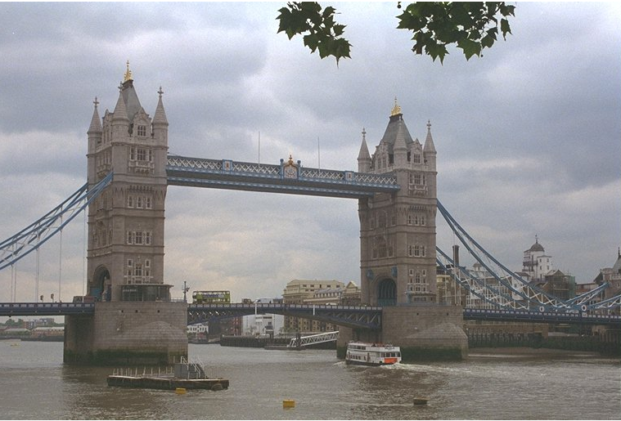
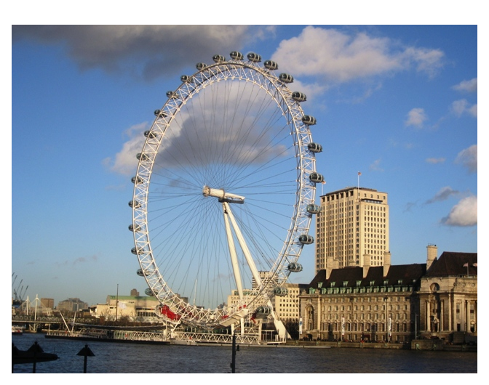
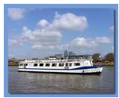

__________________________ ___________________________ _______________________
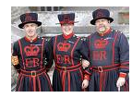
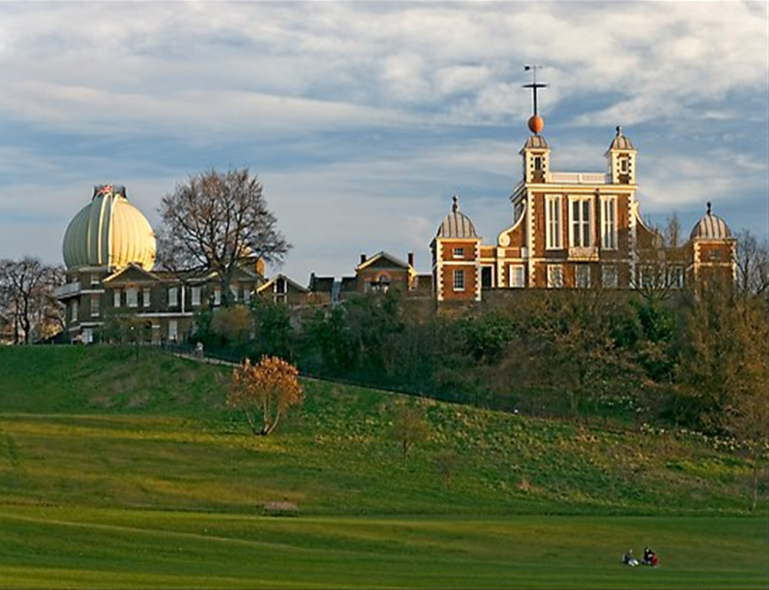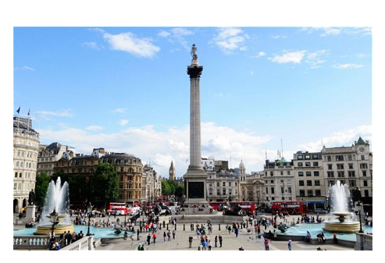

________________________ ___________________________ ___________________________

- Where would you go to see a prison? _________________________________________
- Where would you go to see London from high above? ____________________________
- Where would you go to see wax figures? ______________________________________
- What is your most favourite sight in London and why? _________________________________________________________________________________
________________________________________________________________________________ .

