Unit 4 Name:____________________________ Mark: ___/50

1 Listen and answer the questions.
When is Andrew’s karate lesson?
It's on Thursday, at ten past six._________
1 When has Sarah got a piano lesson?
___________________________________
2 What time is Frank’s party?
___________________________________
3 When’s the football match?
___________________________________
4 What day is the school play?
___________________________________
5 When is Lucy’s dance exam?
___________________________________
 | _____ | 10
2 Read the text and answer the questions.
Melody Club
Do you play a musical instrument? We want more people for our new music club. The Melody Club is on Wednesdays. The club starts at 4.00 pm and finishes at 6.00 pm. It’s in Music room 3, next to the Art room. We sing and we play instruments. We learn new songs every week. Some students write their own songs. It’s a lot of fun!
Please ask Mr Gordon for information.

Film Club
Do you like films? Come to the Film Club on Fridays after school from 4.15 pm to 6.30 pm. We are in Room 24. We watch one film every week and then we talk about it. Some students write about their favourite films for the school website. We’ve got films from the UK, the USA, Europe, South America and Asia. We’ve even got some old black and white films! So, come next Friday and join our club.
Please ask Mrs White for information.
What day is the Melody Club?
The Melody Club is on Wednesday.______
1 What time does the Melody Club start?
___________________________________
2 What do students do at the Melody Club?
___________________________________
3 Where is the Film Club?
___________________________________
4 What do some students write on the school website?
___________________________________
5 Have they got films from the USA and Africa?
___________________________________
 | _____ | 10
3 Choose the correct words.
Our tennis lessons are at / on Sunday.
1 I go to sleep at / on half past nine.
2 Lessons start at / on quarter to nine.
3 The volleyball match is at / on Friday.
4 Janie’s party is at / on Saturday.
5 The football match is at / on two o’clock.
 | _____ | 5
4 Complete the sentences. Choose from these verbs.
not listen go have not write play not take
I don’t write a lot of emails.
1 Dan __________ the bus to school.
2 We __________ to the radio in the morning.
3 Sally and Keith _________ volleyball every week.
4 Maria __________ skiing in the winter.
5 Sarah __________ a shower at quarter past seven.
 | _____ | 5
5 Use the words to write sentences.
Lottie what time / you / get up?
What time do you get up?__________
Rob (1) I / get up / quarter past seven
_______________________________
Lottie (2) you / take the bus to school?
_______________________________
Rob (3) yes / I
_______________________________
Lottie (4) when / your lessons / start?
_______________________________
Rob (5) they / start / quarter to / nine
_______________________________
 | _____ | 5
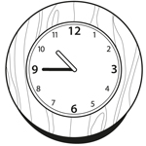
6 Choose the correct alternative.
Is it five to nine?
A Yes, it is.
B No, it isn’t. | 
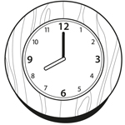
1 Is it nine o’clock?
A Yes, it is.
B No, it isn’t.
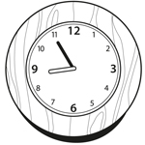
2 Is it five to nine?
A Yes, it is.
B No, it isn’t.
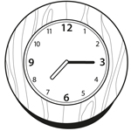
3 Is it quarter past six?
A Yes, it is.
B No, it isn’t.
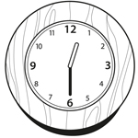
4 Is it half past twelve?
A Yes, it is.
B No, it isn’t.
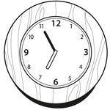
5 Is it five to seven?
A Yes, it is.
B No, it isn’t.

 | _____ | 5
7 Complete the sentences. Choose A or B.

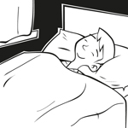
I ____ lunch at school. |  |  |  | 1 I ____ to sleep after I read my book.
A play |  |  |  | A do
B have |  |  |  | B go

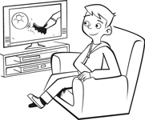 |  |  | 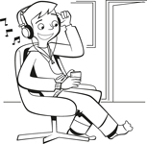
2 I ____ TV with Mum and Dad. |  |  |  | 3 I ____ to music on my MP3 player.
A watch |  |  |  | A go
B play |  |  |  | B listen

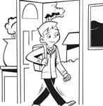 |  |  | 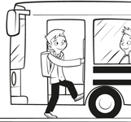
4 I ____ to school with my friends. |  |  |  | 5 I ____ the bus to school.
A go |  |  |  | A go
B do |  |  |  | B take

 | _____ | 5
8 Complete the sentences.
April Hi, Joe. Do you c o l l e c t stamps?
Joe No, I (1) _ _ _’_. I collect posters. Why?
April I’ve got some Australian stamps. My cousin Jane (2) _ _ _ _ _ in Australia. She often (3) _ _ _ _ _ _ me letters. Look!
Joe They’re nice. Do you write letters to your cousin?
April Well, no …, I (4) _ _ _’_ write letters, but I (5) _ _ _ _ to her on the phone or I send emails.
 | _____ | 5

