Unit 3 Grammar

Grammar: have got
- Choose the correct words.
  - Have your parents got a car? Yes, they _____.
    - ☐ haven’t
    - ☐ has
    - ☐ have
  - Has Luke got a pet snake? Yes, he _____.
    - ☐ has
    - ☐ hasn’t
    - ☐ haven’t
  - Has Jerry got a new bike? No, he _____.
    - ☐ has
    - ☐ hasn’t
    - ☐ haven’t
  - Have your friends got DVD players? No, they _____.
    - ☐ have
    - ☐ has
    - ☐ haven’t
  - Has your brother got a computer? Yes, he _____.
    - ☐ have
    - ☐ has
    - ☐ haven’t
  - Has Milly got a budgie? Yes, she _____.
    - ☐ has
    - ☐ hasn’t
    - ☐ haven’t
- Make the sentences positive.
  - They haven’t got a cat.
  - Carla hasn’t got a television in her bedroom.
  - Mum hasn’t got a DVD player.
  - We haven’t got a garden.
  - George hasn’t got two mobile phones.
  - I haven’t got a computer.
- Complete the questions. Choose A or B.
  - ____ you got a parrot?
    - ☐ Has
    - ☐ Have
  - ____ Liam got a CD player?
    - ☐ Has
    - ☐ Have
  - ____ they got any brothers and sisters?
    - ☐ Has
    - ☐ Have
  - ____ Maria got a computer game?
    - ☐ Has
    - ☐ Have
  - ____ you got a rabbit?
    - ☐ Has
    - ☐ Have
  - ____ we got mobile phones?
    - ☐ Has
    - ☐ Have

- Match sentences 1-6 with the pictures A-F.
- Liz has got a computer.  - Jack has got a mobile phone.  - Mum and Dad have got a DVD player.  - Miranda has got a radio.  - Mike and Alec have got cameras.  - Darren has got a bike. | -   - 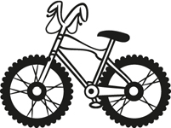  -   - 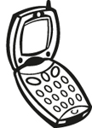  - 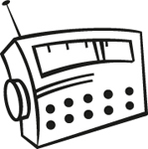  - 
- Complete the sentences with have got or has got.
  - Lulu a pencil.
  - Andy a picture.
  - Tara and Fred exercise books.
  - Kieran a dog.
  - Emily a bike.
  - Ed and William mobile phones.

Grammar: position of adjectives
- Choose the correct words.
  - 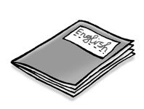
This is a thin book / book thin.
  - 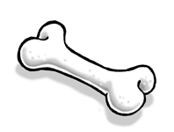
That’s a bone big / big bone.
  - 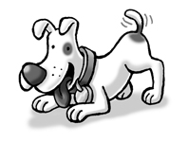
This is a friendly dog / dog friendly.
  - 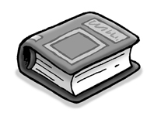
My sister has got a book thick / thick book.
  - 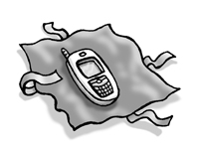
This is my new mobile phone / mobile phone new.
  - 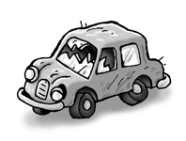
Look at that car old / old car.
- Complete the sentences. Choose from these words.
old - big - new - white - thin - good
  - 
This is a car.
  - 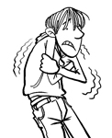
This is a shirt.
  - 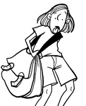
This is a bag.
  - 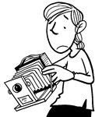
This is an camera.
  - 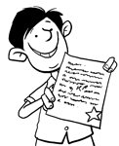
He’s a student.
  - 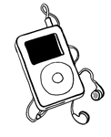
It’s a MP3 player.
- Correct the mistake in the sentences.
  - James has got a camera new.

  - We’ve got a computer game good.

  - It’s a bag big.

  - She hasn’t got eyes big.

  - Molly has got hair short.

  - This is a book thick.

- Put the words in the correct order to make sentences.
  - got / a / blue / I’ve / bike

  - old / an / car / it’s

  - got / has / Danny / radio / small / a

  - computer / they’re / games / new

  - a / she’s / friendly / got / cat

  - long / snake / a / it’s

- Use the words to write sentences.
  - it’s / big / spider

  - they’re / green / parrots

  - we’ve / got / new / MP3 player

  - he’s / got / white / mouse

  - they / haven’t / got / big / television

  - it’s / small / dog

- Complete the sentences. Choose A or B.
  - 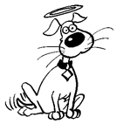.
1 This is a ____.
    - ☐ good dog
    - ☐ thin dog
  - 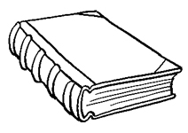.
It’s a _____.
    - ☐ small book
    - ☐ thick book
  - 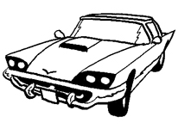.
It’s _____.
    - ☐ an old car
    - ☐ a small car
  - 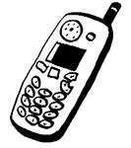.
This is a _____.
    - ☐ big mobile
    - ☐ thin mobile
  - 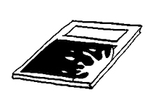.
This is a _____.
    - ☐ new book
    - ☐ thin book
  - 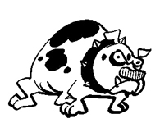.
It’s a _____.
    - ☐ small dog
    - ☐ bad dog
Answer Key

  - C. have
  - A. has
  - B. hasn’t
  - C. haven’t
  - B. has
  - A. has

  - They’ve got a cat.
  - Carla has got a television in her bedroom.
  - Mum has got a DVD player.
  - We’ve got a garden.
  - George has got two mobile phones.
  - I’ve got a computer.

  - B. Have
  - A. Has
  - B. Have
  - A. Has
  - B. Have
  - B. Have

  - F.
  - D.
  - A.
  - E.
  - C.
  - B.

  - has got
  - has got
  - have got
  - has got
  - has got
  - have got

  - thin book
  - big bone
  - friendly dog
  - thick book
  - new mobile phone
  - old car

  - new
  - thin
  - big
  - old
  - good
  - white

  - James has got a camera new.
James has got a new camera.
  - We’ve got a computer game good.
We’ve got a good computer game.
  - It’s a bag big.
It’s a big bag.
  - She hasn’t got eyes big.
She hasn’t got big eyes.
  - Molly has got hair short.
Molly has got short hair.
  - This is a book thick.
This is a thick book.

  - I’ve got a blue bike.
  - It’s an old car.
  - Danny has got a small radio.
  - They’re new computer games.
  - She’s got a friendly cat.
  - It’s a long snake.

  - It’s a big spider.
  - They’re green parrots.
  - We’ve got a new MP3 player.
  - He’s got a white mouse.
  - They haven’t got a big television.
  - It’s a small dog.

  - A. good dog
  - B. thick book
  - A. an old car
  - A. big mobile
  - B. thin book
  - B. bad dog

